**2021 MAA Safety Slogan Contest**

The ever popular annual MAA safety slogan contest is underway. As in year’s past, the MAA Safety Committee is soliciting the entire membership for a short slogan that can be used to help create the 2021 MAA hardhat decals as well as to be used on the 2021 MAA Safety Award banners.

If you have an idea for this year’s slogan please mail, fax or e-mail your ideas on the form below (six words or less), by December 9, 2020 to the MAA office. The winning slogan will be selected by the MAA Safety Committee.

The individual with the winning slogan will receive a $100 visa cash card and will be recognized in our weekly email and on our website.

**Entry Form**

Name:

Company:

Address:

City:       State:       Zip:

Phone:       Fax:

Safety Slogan (six words or less)

Return to the MAA office via fax (517) 381-1796 or e-mail: jhudgens@miagg.org

**Past winning slogans are as follows…**

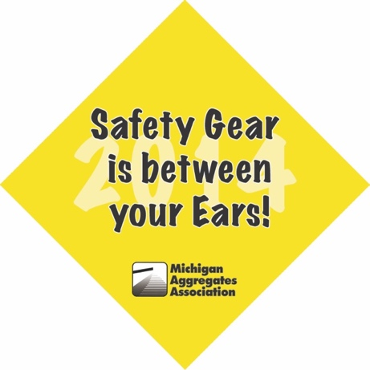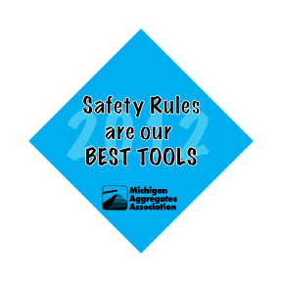../Dropbox%20Files/MAASticker17%20Updated/MAAsticker17.pdf 