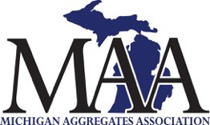
MAA Safety Innovation Submission Form

MAA would like to recognize those who go above and beyond normal safety practices by establishing or developing new ways to be safe. Safety Innovations can be items/practices invented for a specialized use or items/practices that are adapted from other industries and implemented into our own. If you have a Safety Innovation that your company has developed and are following, please submit your idea to the MAA.

Eligibility:
Open to all MAA members. Note: The Safety Innovation being nominated must be in use at the submitting company.

Instructions:
Complete the Safety Innovation Information in Section I below. At least 2 digital photos of the Innovation suitable for publication shall also be submitted. Email the form and photos to Juanita Patson at jpatson@miagg.org

Selection process:
The MAA Safety Committee will evaluate all entries for eligibility. Eligible entries will be reviewed and voted on by the MAA Safety Committee to determine the winner.

All entries must:
- Address a clear safety need.
- Be innovative - Submissions for items/practices that are already recognized as a highly effective way to protect workers will not be chosen as a winner.
- Utilized at the submitting company.
Section I: SAFETY INNOVATION INFORMATION
- Entrants Name:
- Entrants Title:
- Company Name:
- Description of innovative safety item/practice:

- What makes this safety item/practice innovative?

